João Neto, a22200558, turma 1

# Exercício 1:

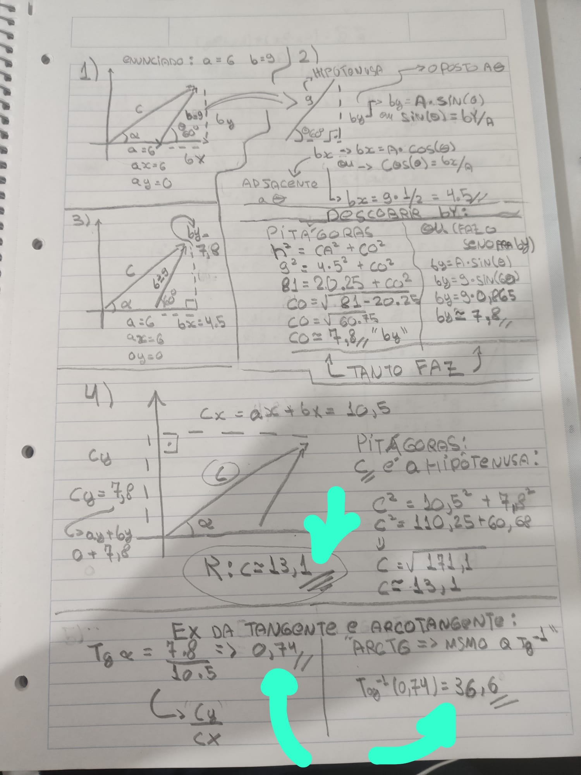

# Exercício 2:

